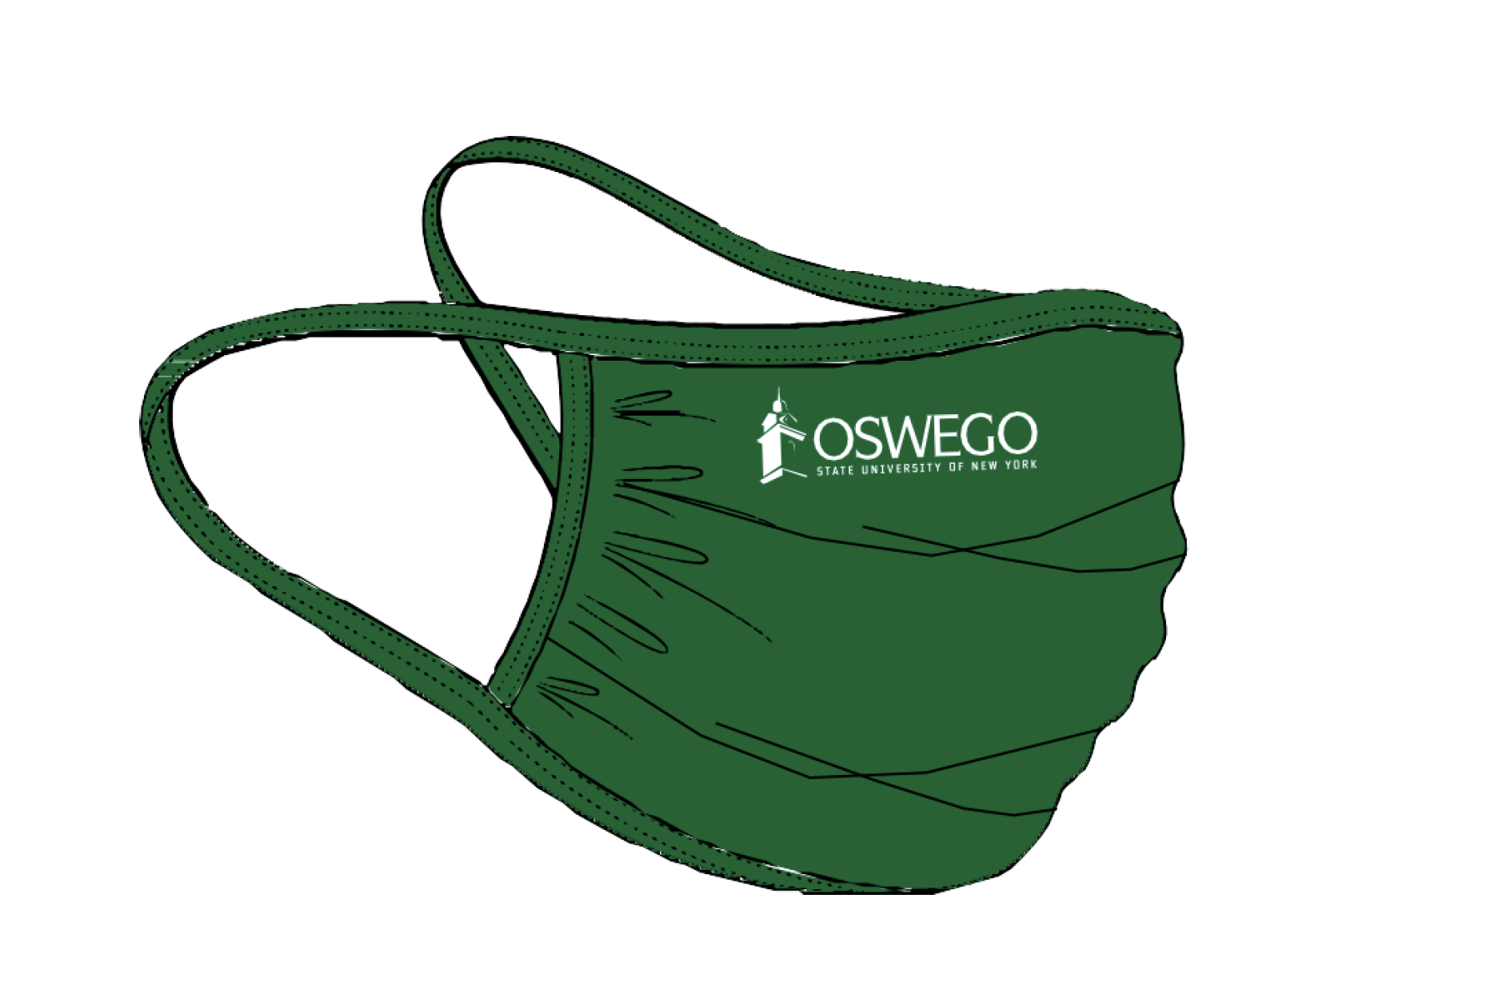

COVID–19 Employee Daily Health Screening

Per the New York Governor's mandate, SUNY Oswego has implemented a COVID-19 Health screening application. All employees are required to complete the electronic form when physically present while working on campus.

Note:
- If you are feeling ill, please stay home. Follow your normal sick call-in procedures.
- If you are coming to campus to work, please complete the COVID-19 Employee Daily Health Screening before arriving (or within the first hour of being on campus if you do not have access to adequate technology). When completing the form, if you cannot verify you do not have any symptoms, stay home and contact your supervisor.
- If an employee begins to feel ill during the day while working on campus, please complete the Employee Daily Health Screening, notify your supervisor and leave work.
- All employees and supervisors will receive an email confirming that the employee has successfully completed and submitted the electronic form.
- Supervisors should ensure that all employees working on campus complete the Daily Health Screening form. Supervisors should follow up with any employee that has not completed the screen.

How To Use QR code:
1.) Launch your camera on your phone.
2.) Point to the QR code.
3.) Depending on the capability of your phone: a notification banner will appear at the top of the screen to click on and direct you to the health screening application OR you can press and hold your home button and the link to the health screening application should appear for you to click on.
4.) OR you may need to download a free QR code reader on your phone which will also work.

Take the COVID-19 Health Check App
